**Directives deepdive**

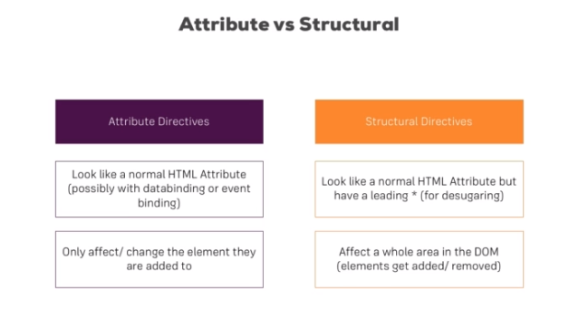

**ngFor and ngIf Recap**

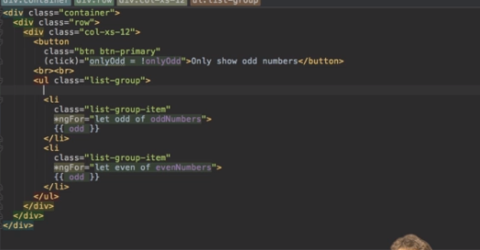

**ngClass and ngStyle Recap**

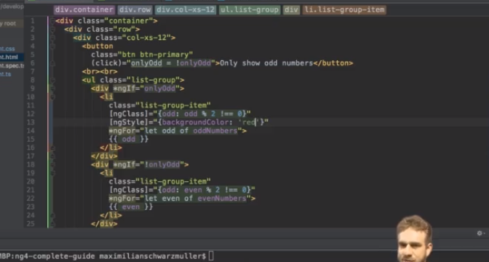

**Creating a Basic Attribute Directive**

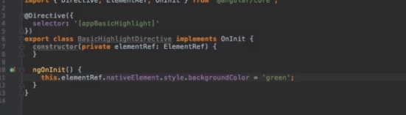

**Building and Using a Dropdown Directive**

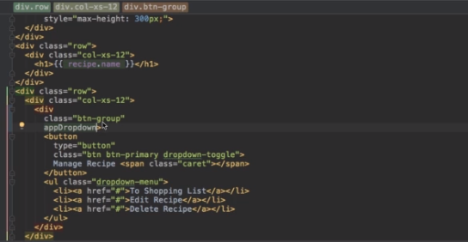

**Closing the Dropdown From Anywhere**

If you want that a dropdown can also be closed by a click anywhere outside (which also means that a click on one dropdown closes any other one, btw.), replace the code of dropdown.directive.ts by this one (placing the listener not on the dropdown, but on the document):

    1. import {Directive, ElementRef, HostBinding, HostListener} from '@angular/core';

    2.

    3. @Directive({

    4.   selector: '[appDropdown]'

    5. })

    6. export class DropdownDirective {

    7.   @HostBinding('class.open') isOpen = false;

    8.   @HostListener('document:click', ['$event']) toggleOpen(event: Event) {

    9.     this.isOpen = this.elRef.nativeElement.contains(event.target) ? !this.isOpen : false;

    10.   }

    11.   constructor(private elRef: ElementRef) {}

    12. }